Cyber Security Research & Practice Platform for Financial Services

User Manual

Version 1.9

Feb/10/2017

VERSION HISTORY

|  |  |  |  |
| --- | --- | --- | --- |
| **Version #** | **Implemented**  **By** | **Revision**  **Date** | **Reason** |
| 1.6 | Harry | 19/12/2016 | API specifications for A2 deliveries |
| 1.7 | Harry | 11/01/2017 | Add Section 2.2 |
| 1.8 | Harry | 08/02/2017 | Add Section 2.1, Section 4.4 |
| 1.9 | Grace | 10/02/2017 | Revise Section 2 |

# A2 Deliverables: OPENVPN

We aim to generate simulated OpenVPN network traffic and build a traffic detector, which describes how likely a given piece of network traffic resembles an OpenVPN traffic.

## OpenVPN GENERATOR

This generator is used for purposes of simulations, observations of OpenVPN key negotiation and OpenVPN packet detection. Our generator can generate the real traffic packets with OpenVPN protocols from one sender to one receiver. Furthermore, our generator can simulate multiple OpenVPN connections in one computer, where the user can set the number and type(s) of the traffic. The generated packets would not be sent out, but you can capture them through our OpenVPN detector or other packet sniffing tool like Wireshark. Because of the implementation details of OpenVPN, only the traffic following OpenVPN of 1-1 scenario (from one sender to one receiver) can be simulated, and the scenarios of multi-1 (from multiple senders to one receiver) and 1-multi (from one sender to multiple receivers) do not exist in real applications, which are not considered in our OpenVPN generator.

### API specification

In A2 deliveries of the generator part, we develop one API, which is used in sender’s side. And the receiver’s side is not limited.

|  |  |  |  |
| --- | --- | --- | --- |
| **Method** | **Params** | **Remark** | **Position** |
| **packet_generator** | srcl, dstl, layerl, num_people | *srcl[i], dstl[i] and layerl[i] contain information of ith OpenVPN connection.* | *ts2/main/views/detector.py* |

|  |  |  |
| --- | --- | --- |
| **Params** | **Values** | **Description** |
| srcl | list of string | *Contains source IP address* |
| dstl | list of string | *Contains destination IP address which is OpenVPN server address* |
| layerl | list of int | *Contains type of OpenVPN traffic. 0 is udp and 1 is tcp.* |
| num_people | int | *Length of srcl, dstl and layerl* |

**1.1.2 Scenario**

We consider the following four scenarios for generating the OpenVPN traffics:

1. Scenario 1: Generate the UDP OpenVPN packets from one sender to one receiver;
2. Scenario 2: Generate the UDP OpenVPN packets from multiple senders to multiple receivers;
3. Scenario 3: Generate the TCP OpenVPN packets from one sender to one receiver;
4. Scenario 4: Generate the TCP OpenVPN packets from multiple senders to multiple receivers;

Scenario 2 and 4 simulate the multiple OpenVPN connections.

## OPENVPN ONLINE DETECTOR

Our OpenVPN detector can judge if a packet is following OpenVPN protocol. The packet can be either monitored within a real-time internet traffic or is recorded by offline data.

Online detector can monitor a real-time internet traffic and respond the number of captured packet in the internet traffic. After monitor, system will display data and diagram to describe situation of OpenVPN traffic and give a link for captured OpenVPN packet. Online detector consists of two part: Packets capturer and packets detector.

We capture packet with help of scapy, which is a GNU licensed open-source python project from Github. For every captured packet, we use our own developed detector to analyse if it is an OpenVPN packet. Although accuracy can't reach 100%, it can detect OpenVPN packet which doesn't use an official 1194 port and reach relative high accuracy on OpenVPN packets with opcode 5, 7 and 8. Besides, OpenVPN detector will generate a log page which helps make a judgement.

**1.2.1 API specifications**

In A2 deliveries of the detector part, we develop two APIs.

|  |  |  |  |
| --- | --- | --- | --- |
| **Method** | **Params** | **Remark** | **Position** |
| **judge_valid** | pkt | *Return a tag number of packet. 0 is non-OpenVPN packet. 1 is OpenVPN packet. 2 is suspicious OpenVPN packet.* | *ts2/main/views/detector.py* |
| **test_type** | pkt | *Return opcode of packet. 0 is non-OpenVPN packet.* | *ts2/main/views/detector.py* |

|  |  |  |
| --- | --- | --- |
| **Params** | **Values** | **Description** |
| pkt | Ether | *A scapy format packet. Scapy packet has format like* Ether()/IP()/UDP()/Payload |

## User manual

### Configuring the environment (For MacOS&Linux)

1. Install python2.7 from https://www.python.org or https://anaconda.org (recommended)

2. Install Django by pip (pip install Django==1.10.4)

3. Install netifaces-0.10.5 by pip (pip install netifaces)

4. Install scapy by pip (pip install scapy)

5. Install ecdsa by pip (pip install ecdsa)

6. Install libdnet-1.12 from https://github.com/todototry/scapyInstallDependents

7. Install PyX-0.10 from https://github.com/todototry/scapyInstallDependents

8. Install pypcap-1.1.4 from https://github.com/todototry/scapyInstallDependents

9. Install Django channel by pip (pip install -U channels)

10. Install redis server by pip (pip install asgi_redis)

11. Install Django-chartjs by pip (pip install django-chartjs)

**1.3.2 Using the system (For MacOS/Linux)**

1. In the terminal, make working directory to ts2.

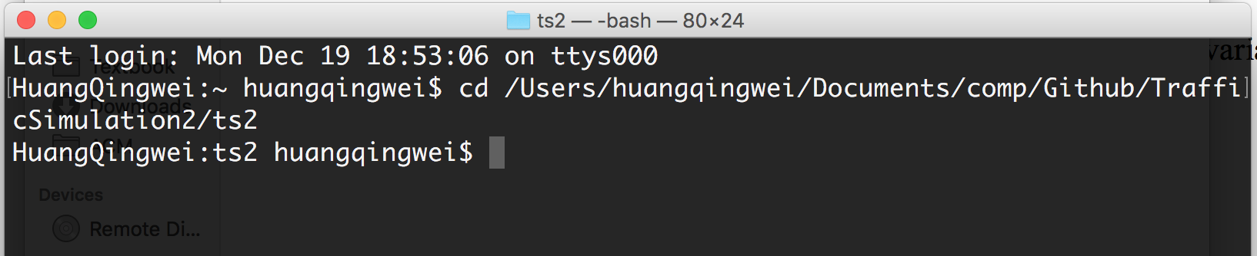

2. Open redis server.

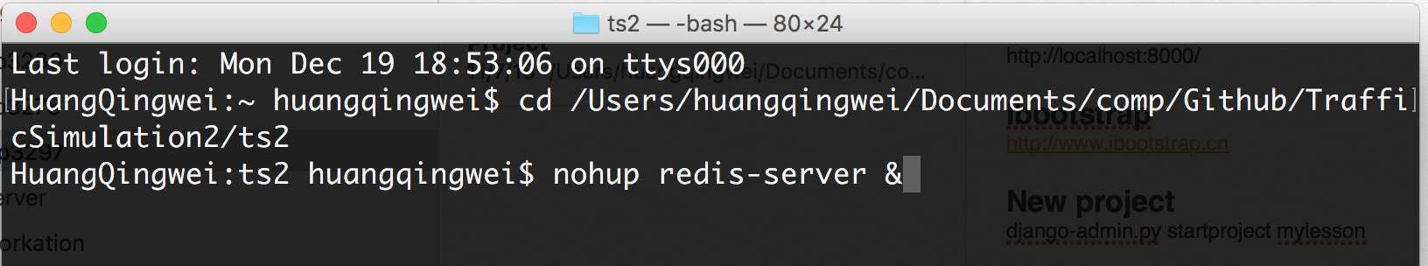

3. Open Django server at local host.

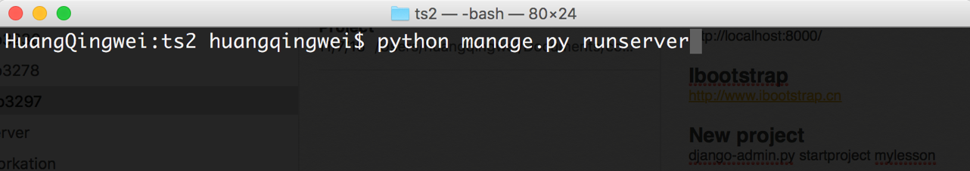

4. Visit localhost:8000 through your browser.

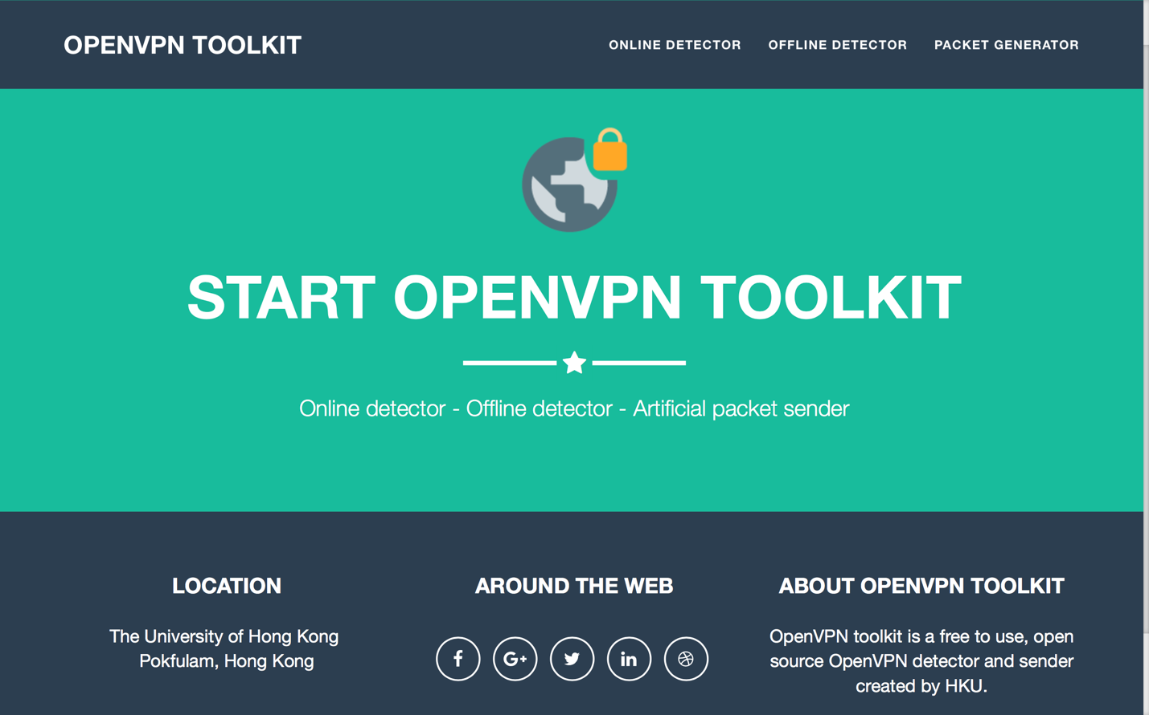

### Using the system in API (For MacOS/Linux)

**1.3.2.1 Using detector API**

**1. In the terminal, make working directory to ts2/main/views/**

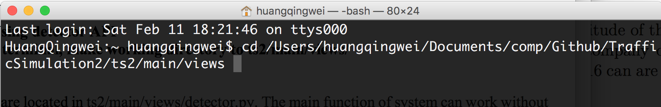

**2. Run python in the terminal**

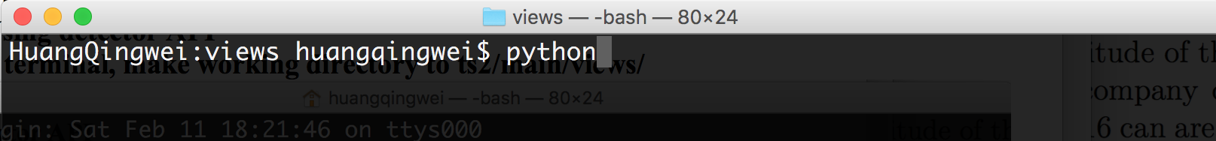

**3. Import detector**

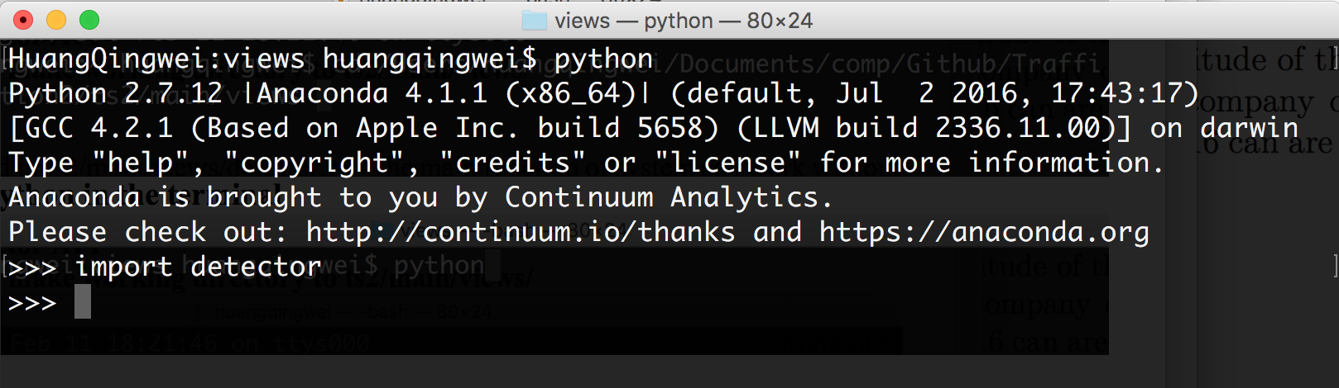

**4. Import scapy**

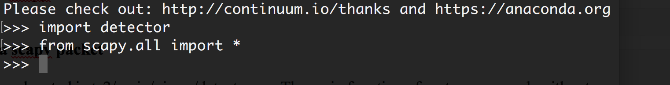

**5. Make a scapy packet**

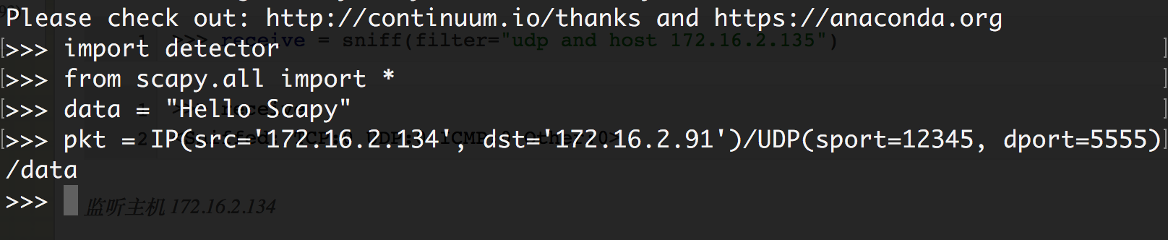

**6. Get the opcode of the packet through test_type( )**

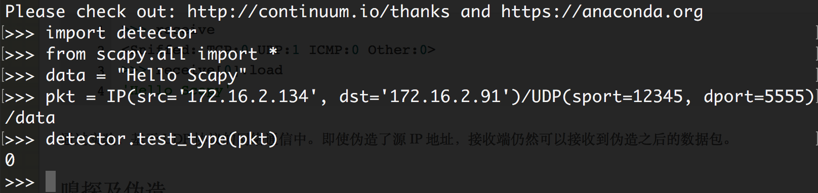

**7. Judge if the packet is following OpenVPN packet through judge_valid( )**

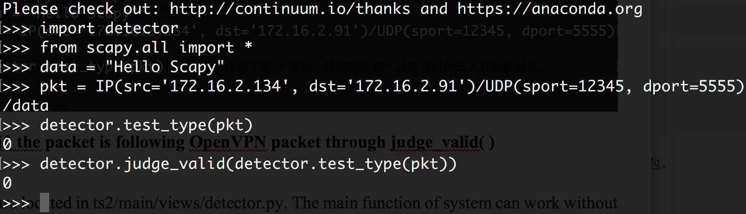

**1.3.2.2 Using generator API**

**1. In the terminal, make working directory to ts2/main/views/**



**2. Run python in the terminal**



**3. Import detector**



**4. Import scapy**



**5. Prepare parameter**

For example, we want to simulate two OpenVPN connections at the same time.

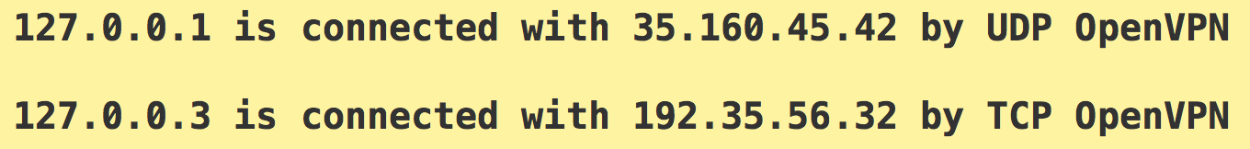

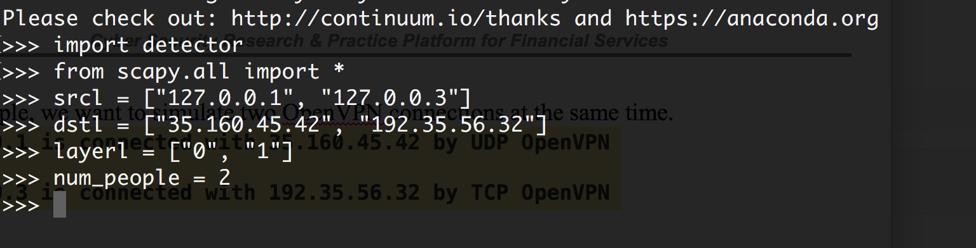

**6. Simulate through packet_generator( )**

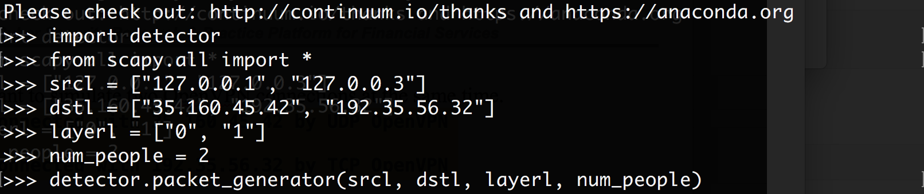

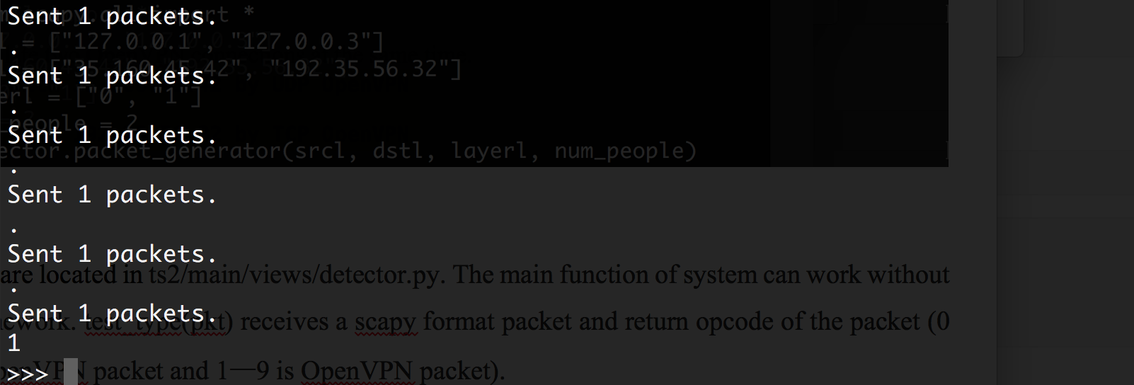

### Results when using index.html

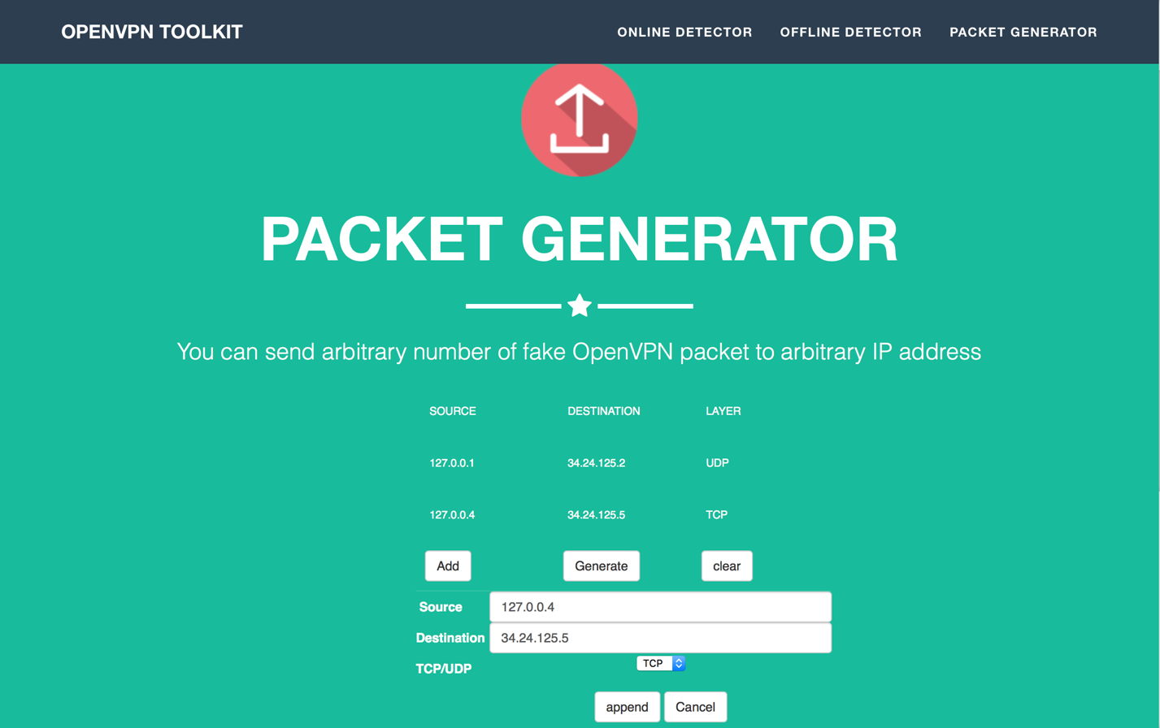

Generator





Online detector

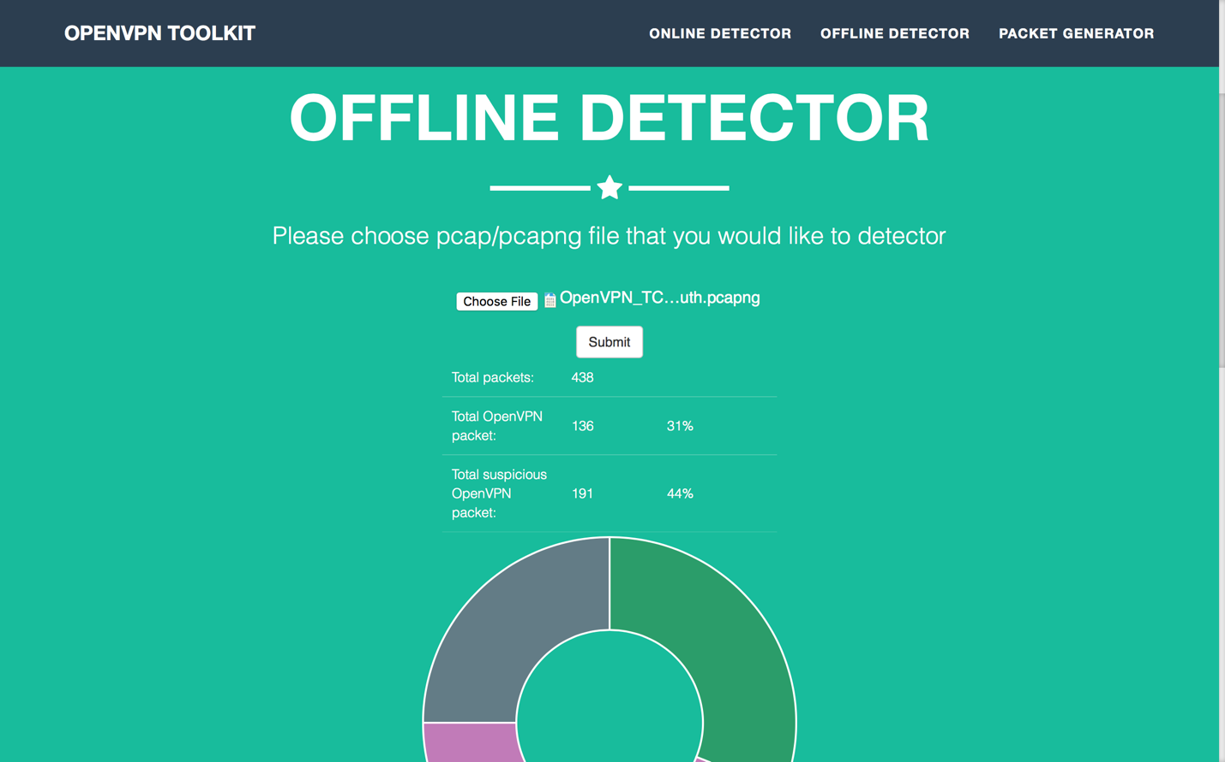



Offline detector

### Passed testing cases

|  |  |  |  |  |
| --- | --- | --- | --- | --- |
|  | Description of testing case | Testing data | Recall (Wireshark) | Recall  (Our detector) |
| 1-a | TCP OpenVPN packets | Total 438 packets, which contains 327 real OpenVPN packets, 111 TCP packets (Data source: Wireshark official website <https://wiki.wireshark.org/OpenVPN> ) | 100% | 100% |
| 1-b | TCP OpenVPN packets | Total 103 real OpenVPN packets, which contains 91 real OpenVPN packets (Data source: captured by scapy, we manually label the packet as either an OpenVPN packet or not) | 0% | 88.35% |
| 2-a | UDP OpenVPN packets | Total 440 packets, which contains 439 real OpenVPN packets, 1 icmp packets (Data source: Wireshark official website <https://wiki.wireshark.org/OpenVPN> ) | 100% | 100% |
| 2-b | UDP OpenVPN packets | Total 122 packets, which contains 74 real OpenVPN packets (Data source: captured by scapy, we manually label the packet as either an OpenVPN packet or not ) | 0% | 60.66% |
| 3 | Other protocol packets | Total 1608 non-openVPN packets, which contains 1385 udp packets, 2 tcp packets, 1oicp packet, 5 nbns packets, 139 mdns packets…… (captured by Wireshark) | 100% | 99.81% |

*

# Discussions

# 2.1 Theory of Detecting Openvpn

The difficulty in OpenVPN detecting mainly relies on encrypted payload and poor information header. There are 9 types of OpenVPN packets in total.

P_CONTROL_HARD_RESET_CLIENT_V1

P_CONTROL_HARD_RESET_SERVER_V1

P_CONTROL_SOFT_RESET_V1

P_CONTROL_V1

P_ACK_V1

P_DATA_V1

P_CONTROL_HARD_RESET_CLIENT_V2

P_CONTROL_HARD_RESET_SERVER_V2

P_DATA_V2

Their headers are different. The header of P_CONTROL_HARD_RESET_SERVER_V2 has richest information which is

|  |
| --- |
| opcode 1 bytes |
| session ID 8 bytes |
| HMAC 20 bytes or 16 bytes |
| packet-id 4bytes |
| net time 4bytes |
| message packet-id array length 1bytes (n) |
| message packet-id array element 4*n bytes |
| remote session id 8 bytes |
| message packet-id 4 bytes |

We first check if opcode is a valid value between [1, 9]. Then we calculate packet's length according to message packet-id array length and check if it is same as length described in udp header. However, for type like P_DATA_V1 whose header has poorest information like

|  |
| --- |
| opcode 1 bytes |
| encrypted data n bytes |

It is hard to tell if it is an OpenVPN packet. Our detector works well on P_ACK_V1, P_CONTROL_HARD_RESET_CLIENT_V2, P_CONTROL_HARD_RESET_SERVER_V2 whose headers have more valuable information. It is meaningful to monitor an internet traffic because an OpenVPN traffic must contain those three type of packets.